**Experiment 6**

**Job Chaining in Jenkins**

**Aim**

To understand and practice job chaining in Jenkins.

1. Create a Maven Project pipeline JOB1



1. Create another pipeline JOB2
2. Choose Configure > Build other projects

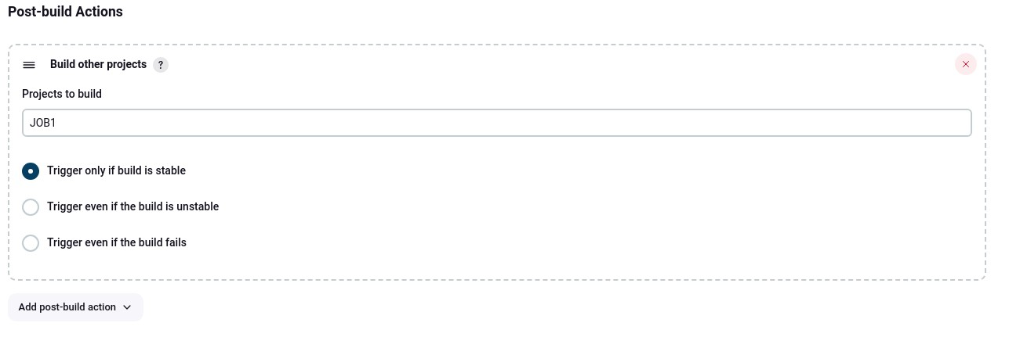

1. Previous job is now showing as Upstream Project in the new job

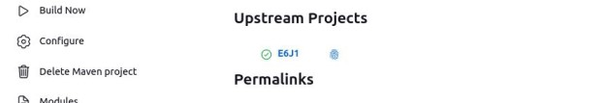

1. Test the chain by building the first pipeline

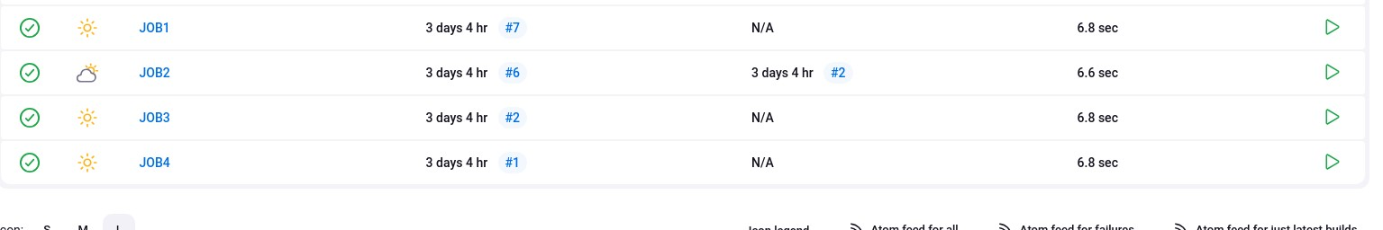

1. Create 1 more pipelines JOB3, creating a longer and branched chain
2. Test the complete pipeline chain by running JOB1

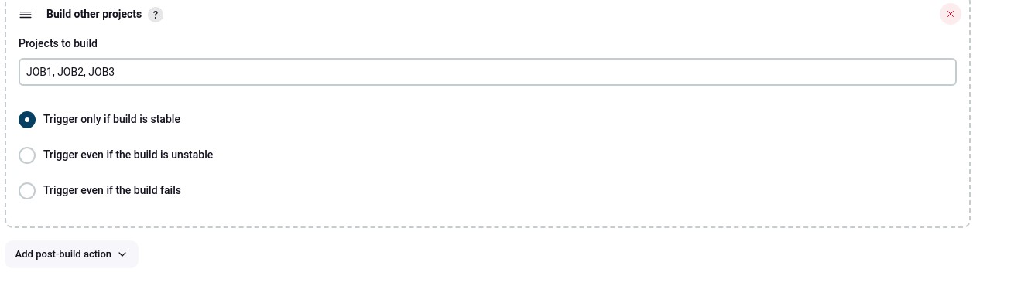



1. Checking logs

a. JOB1 triggered JOB2 once it succeeded

